Edition 6

Date: 03/02/2025

## INTRODUCTION

Welcome back everyone!

In this edition, I’ll speak about the progress of book 2 of the “Insignitis” series, subtitled: Bloodstone, topics I use, and include a book suggestion.

Once again, Joshua’s (who designed the cover for book 1) website is: www.joshuagriffinart.com. Please have a look at his work.

PROGRESS OF BOOK 2

I began writing book 2 in October 2024. It has slowly progressed due to family commitments, and holidays.

However, I have written sixteen chapters. Sadly, my laptop broke thus I have had to go “old school”, and handwrite six of them. Luckily, 10 were already typed, and saved! But I am buying a PC soon!

The progress of book 2 may be slow, but the Main Characters (MCs) have not!

There is a new antagonist, but they are not alone. The other in their wake is keeping secrets, and not just from the antagonist.

TROPES

First: What is a (book) trope?

A trope is a recurring plot device, character archetype, or thematic element that appears in different genres of books. Essentially, it is considered a “storytelling shortcut” easily grasped by the reader(s).

The tropes in **book 1** of the Insignitis series: **Destiny**, are:

* Slow Burn
* Romance
* Prophecy
* Family
* Spice (sexual content, commonly with trigger warnings attached)
* Myth and Magic
* Revenge
* Self-Discovery/Personal Growth, and
* Truth and Lies.

Usually a book series contains some of the same tropes. In book 2:

* Slow Burn
* Romance
* Family
* Spice
* Myth and Magic, and
* Revenge.

The **new tropes** in book 2 are:

* Family Feud
* Reluctant Hero
* Cassandra Truth (Hidden Truth)
* Magical Artefacts
* Medieval Settings
* The Quest

MYTHICAL CREATURES

I have read mythology since I was a teen. It is something I am always learning with each book I own.

Book 1 was heavily based on Celtic mythology thus book 2 will, too.

Before I start writing, I research mythology by using the encyclopaedias I own. I then choose which to use, and which to use as the antagonist.

In **book 2**, most of the creatures from book 1 will appear:

* Elves
* Mages
* Seers
* Pegasuses, and
* Fae

In **book 2,** however, I shall be using:

* Gods and Goddesses, and
* Others

The others I won’t reveal to prevent spoilers. However, I will reveal that the antagonist is a Fae.

Unlike today’s version of fae, which has been made child-friendly, I keep in tone with the mythology of the creatures. Fae are not “cute Tinklebell fae”. They are actually really dark. This, in my opinion, makes them a great option for an antagonist.

BOOK SUGGESTION

I have recently read a series by Cynthia Wilde: Burning Falls Shifters. It is a spellbinding series involving romance, myth, and feuds between other shifters and the human population, who are (mostly) unaware of their existence. I finished the entire series, which contains 5 books, within three days. So, I highly recommend this series!

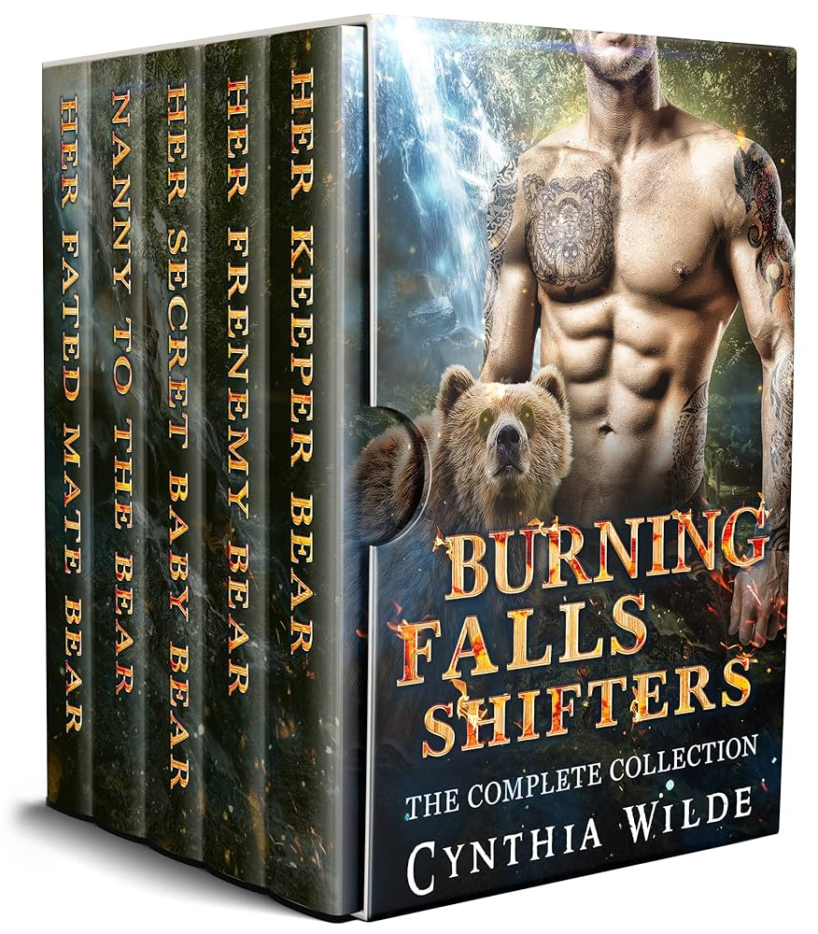

FRIENDLY GOODBYE

It’s been wonderful to write this edition of my newsletter, and I hope, my fellow readers, writers, and authors, enjoyed reading this new edition!

Until next time: keep reading, and creating wonderful stories! Feel free to contact me on my social media platforms!